Design Manual

1．Introduction 2
1.1 Purpose of this document 2
1.2 Project background and goals 2
1.3 Definition 2
1.4 Refrences 2
2．Design 3
2.1 Requirement overview 3
2.2 Schematic diagram of program structure 3
3．Program Description 4
3.1 Function 4
3.2 AI workflow diagram 9
3.3 Interface 13

1．Introduction

1.1 Purpose of This Document
This document provides game players and AI vs player chess software developers with a better understanding of the overall design of software development, algorithm design principles, and helps for secondary developers.

1.2 Project Background and Goals
The goal of this project is to develop an AI system that can automatically evaluate the current state of a chess game and provide the best move according to its analysis. The system will be presented through a graphical interface that displays the chessboard and the current state of the game as it progresses through human and AI moves.
It mainly has the following functions:
- Graphical interface display (showing window controls for user interaction, displaying the chessboard and chess pieces)
- AI evaluation settings (search depth, setting values for the relative strength of different chess pieces)
- Game player selection of game mode (both sides controlled by AI, one side controlled by AI and switchable, both sides manually controlled by players)
- Game player initiation and progression of gameplay
- AI automatic evaluation and completion of human-machine gameplay
- Software checks for compliance with game rules in move decisions
- Software detects game end conditions (checkmate, stalemate, etc., or if more than 50 moves have been played without a capture)
- Software timing move decisions.

1.3 Definition

Min-max search: the minimax algorithm

Pruning search: alpha-beta pruning

C#: The project is coded in the C# programming language.

WinForms: The graphical interface uses the Windows Forms API.

Visual Studio 2017: The development environment, with a framework of .NET Framework 4.6.

1.4 References
Minmax Algorithm in game theory
https://www.geeksforgeeks.org/minimax-algorithm-in-game-theory-set-1-introduction/

Alpha-Beta Pruning
https://www.geeksforgeeks.org/minimax-algorithm-in-game-theory-set-4-alpha-beta-pruning/

2．Design

2.1 Requirements overview

Construct a model and related methods for chess movement rules based on the rules of international chess;

Implement AI that automatically responds to player moves to form a game;

Implement a graphical interface to display the game progress and board state for both players;

Provide prompts for capturing pieces or putting the opponent in check.

Record the game history log for both players.

2.2 Schematic diagram of program structure
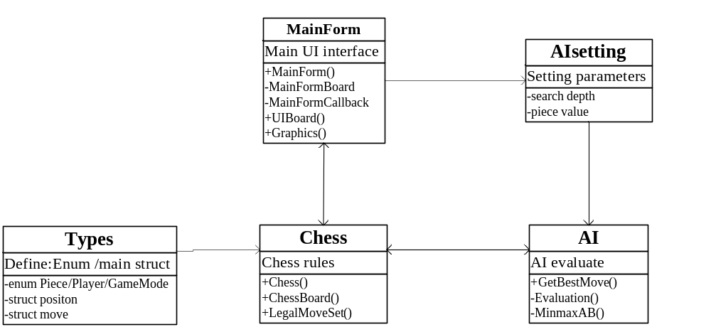

- Chess is a class that controls the logical operation of the game and forms the core of the software. It has two independent auxiliary classes: ChessBoard and LegalMoveSet. ChessBoard mainly records the current state of the chessboard in various forms. LegalMoveSets is a chess rule class used to determine whether a move is legal and whether the game is over. It can also form the action set of each chess piece under the current state.
- MainForm is the form that runs the game and serves as the UI. It has two shadow forms, MainFormBoard and MainFormCallbacks, to ensure smoother interface operation.
- AI is an AI that evaluates values and uses a minimax search with alpha-beta pruning to make the best move decisions.
- Types define various enumeration values and structures required by the system, such as chess piece enumeration, player enumeration, game mode enumeration, chess piece position structure, and chess piece movement model structure.
- AIsetting allows users to set the game difficulty (search depth) and chess piece strength values through the FrmSetting form interface to affect the AI evaluation results.

3．Program description

3.1 Functions
3.1.1 Graphical display of chessboard and chess pieces
Feature Description: The main interface displays an 8x8 square international chessboard in a graphical manner, with chess pieces displayed on the chessboard. When the participant or organizer starts or resets the game, the function of initializing the display of the chessboard should be achieved. After the game starts, the chessboard displays the game position and is constantly updated as both sides make moves. 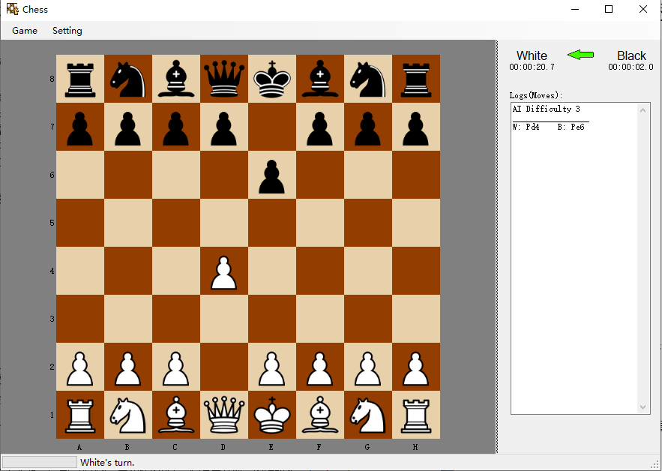

3.1.2 Playing games in different modes
The following modes can be used for playing games:：
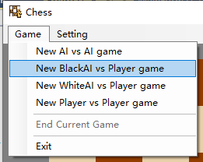
- AI vs AI;
- Black AI vs Player
- White AI vs Player
- Player vs Player

Where "Player" refers to a human player using the mouse to click on a chess piece and select its move location to complete a move, and "AI" refers to this software directly reading information from the AI to complete a move without user confirmation. Before starting a game, players should be able to create one of these modes from this software.

3.1.3 AI Setting
The AI can be configured with parameters such as difficulty level and piece values to accommodate players of different skill levels.
- Difficulty setting: Difficulty is divided into beginner, easy, medium, difficult, very difficult levels, which correspond to the analysis depth of AI. Beginner, easy, medium, difficult, and very difficult correspond to analysis depth levels of 1 to 5, respectively. When the analysis depth is 3, the AI response time is about 5-6 seconds; when the analysis depth is 4, the AI response time is about 20 seconds; when the analysis depth is 5, the AI response time is about 2-5 minutes (or even longer depending on the board state).
- Strength value: The setting of strength values for each chess piece is to better evaluate the optimal move position and can be set from 1 to 999.After the settings are completed, they are only saved in the memory of the current software session and have not been saved to the local device. If you want to save them, you can handle it appropriately.

3.1.4 Human-computer interaction: handling user interactions, enabling automatic and manual gaming, and determining whether moves comply with the rules. When the user clicks on their piece, the system displays all possible move positions by highlighting the squares with different colors. All positions where the player can capture a piece are highlighted in red, while positions where the player can move without capturing are highlighted in yellow. The sound effects for moving, capturing, and check have also been appropriately distinguished.
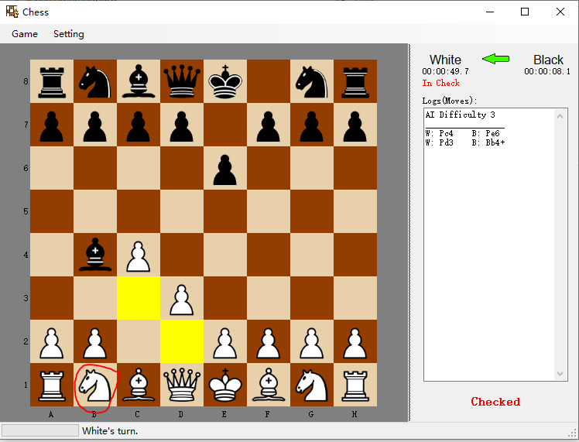
3.1.5 Game timing
To ensure that the AI's thinking time is controlled, the system separately tracks the time used by each player during their turn. When it is the black player's turn, the waiting time before making a move is accumulated and recorded as the time used by the black player. During the AI's thinking period, a progress bar in the lower-left corner of the interface displays "AI thinking..." to indicate that the AI is computing its move.

3.1.6 History record and current turn indicator:
- Current turn: The lower left corner will display whether it is White or Black's turn to play. At the same time, the green arrow in the upper right corner will point to White or Black accordingly.
- Check: When one player is in check, it will display "In Check" below the timer and "Checked" in the lower right corner.
- History record: The "Log (Moves)" box will record the abbreviated moves of both White and Black. The record starts with "W:" for White and "B:" for Black, followed by the abbreviation of the piece moved. P for Pawn, N for Knight, B for Bishop, R for Rook, Q for Queen, and K for King. Then, the destination coordinate is listed, such as "Pc4" for Pawn moving to c4. If the move puts the opponent's King in check, it is marked with a "+". If a piece is captured, it is marked with an"x".
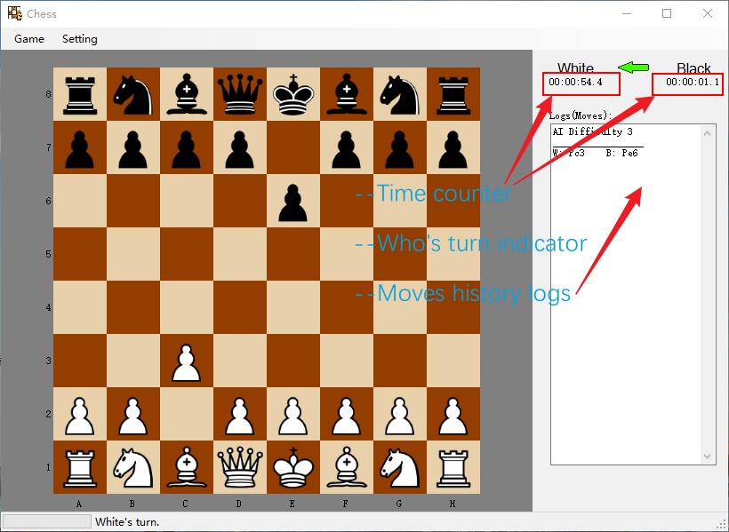

3.2 AI Workflow Diagram:
According to the rules of chess, the basic workflow of determining AI is as follows:
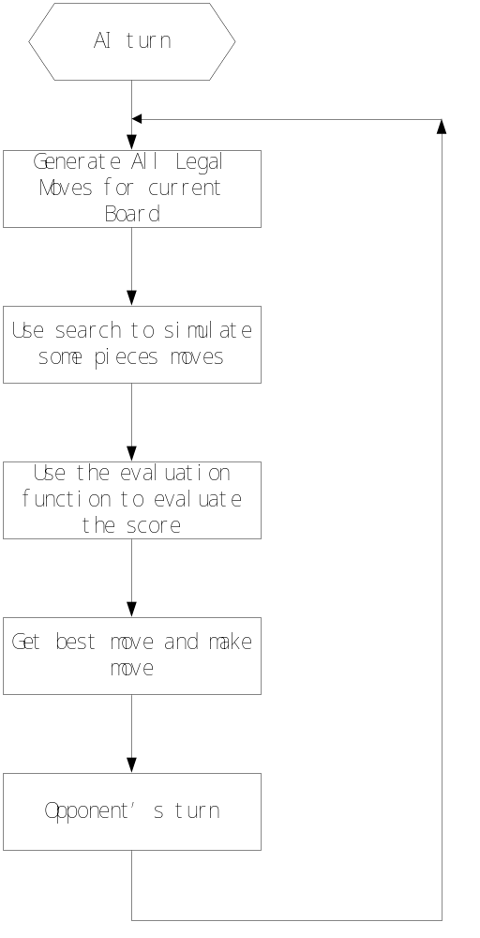

By utilizing the LegalMoveSet.getPlayerMoves function to obtain a dictionary of all legal moves for our side, the program conducts a search based on evaluation to ultimately determine the optimal move for our side. The search and evaluation functions work together to enhance the AI's "thinking" ability from two aspects:：
• Evaluation function: directly impacts the AI's choices by evaluating the quality of the game state.
• Search method: accelerates the search speed and reduces the time required for deep searches, providing the potential to deepen the search depth and improve the AI's long-term and comprehensive "thinking" abilities.
STEP1: Iterate to get all possible walking methods.
In this step, the LegalMoveSet.getPlayerMoves library will be used to iterate through moves and calculate all possible legal moves for a specific chess position.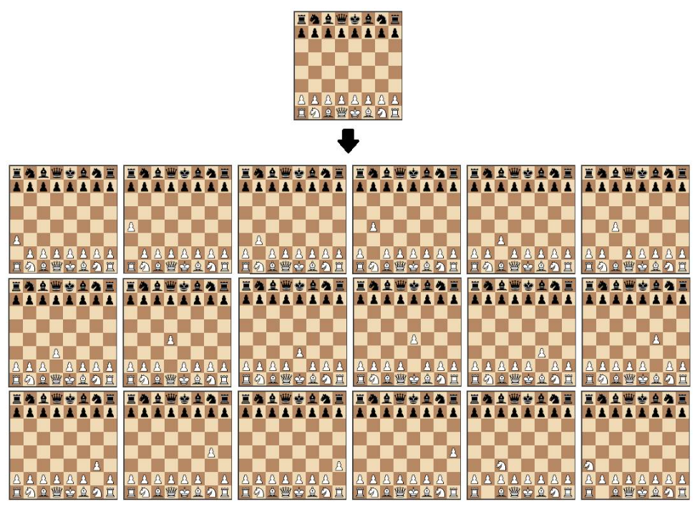
STEP2: Simulated moves and position evaluation
This section aims to determine which side has the advantage in a given chess position. The simplest method is to calculate the relative piece value of each chess piece on the board using a table. Through the evaluation function, we can obtain the move that maximizes the calculated evaluation value. However, in this case, all possible moves need to be calculated, which requires high computational power and is time-consuming.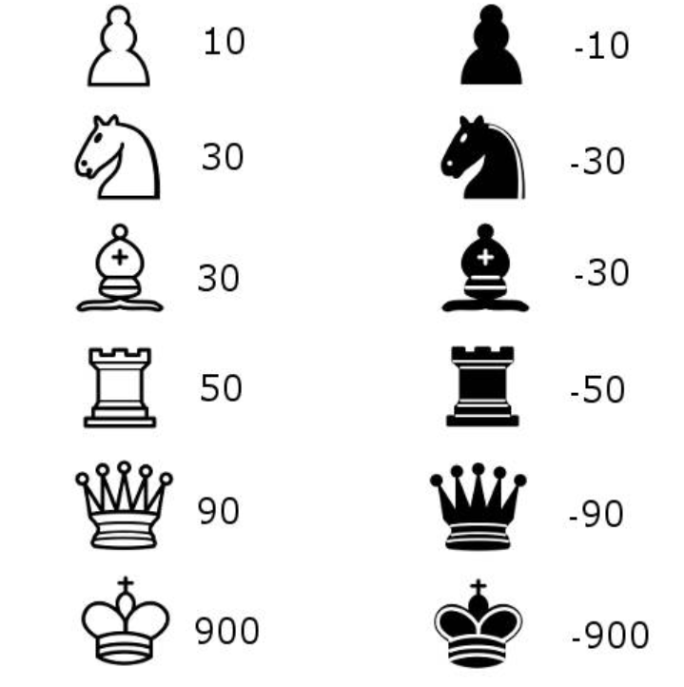
STEP3 Search tree using the minimax method
The algorithm constructs a search tree to choose the best move, using the minimax algorithm, which is widely used in decision theory, game theory, and statistics. Its basic principle is to minimize the loss under the worst possible scenario (i.e., the maximum possible loss). This algorithm searches all possible paths of the recursive tree based on a given depth and gives an evaluation at the "leaf" node. After that, the algorithm returns the minimum and maximum values from the child nodes to the parent node depending on whether it is the turn of the white or black player.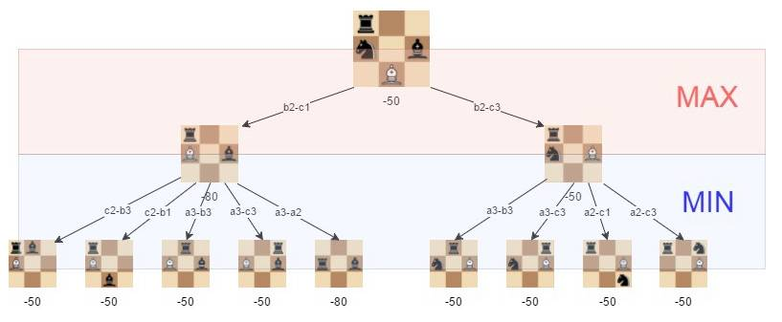
As shown in the above figure, the best move for white (our side) is b2-c3, as we can minimize the loss to -50.
The effectiveness of the Minimax algorithm relies heavily on the depth of search we implement, which we will continue to optimize.
STEP4 Alpha-beta pruning
Alpha-beta pruning is an optimization technique for the Minimax algorithm, which involves cutting off certain branches during the search process. This can save computational resources and increase the depth of the algorithm. The pruning algorithm abandons a branch if it discovers that the branch will lead to a worse outcome. This method does not affect the Minimax algorithm but can speed up the algorithm. Of course, if the optimal path can be found at the beginning, the alpha-beta algorithm will be more effective.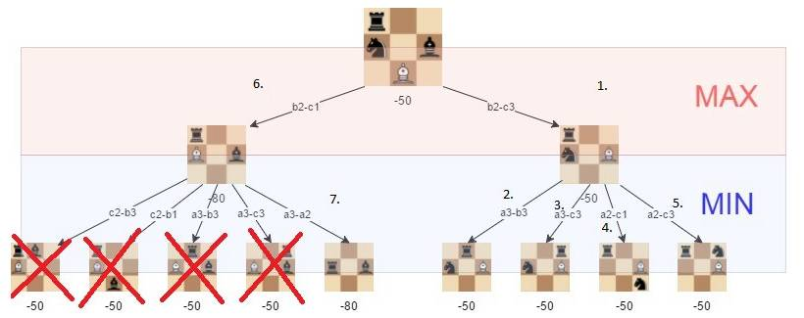
STEP5 Improving the evaluation function

To optimize the function, we added a factor that evaluates the position of the chess pieces. For example, a knight in the middle of the board is better than one in the corner (because it has more moves and is more active).

3.3 interface
API document.chm
